|  |  |  |  |  |  |
| --- | --- | --- | --- | --- | --- |
| 6,000 lb. Maximum Lifting Capacity **36,000 ft.-lb. Maximum Moment** | | | | |  |
|  |  | |  |  |
|  |  | | | |
| **Compliance to Specifications** | The Bidder shall indicate their compliance by checking "Yes" or "No" for each item specified. Any space not checked shall be interpreted as non-compliance and will result in disqualification of the bid. | | | |
|  |  | |  | |  |
| **Make & Model** | **EHC-6 NexStar** | | **Comply to Specification** | | Deviation from Specification |
|  |  | | **Yes** | **No** |
|  |  |  |  |  |  |
| Capacity (Measured from Center of Rotation) | 6,000 lb. @ 6 ft. | |  |  |  |
| 4,500 lb. @ 8 ft. | |  |  |  |
| 3,600 lb. @ 10 ft. | |  |  |  |
| (See full load and stability charts attached for reference) | 3,000 lb. @ 12 ft. | |  |  |  |
|  | 2,571 lb. @ 14 ft. | |  |  |  |
|  | 2,250 lb. @ 16 ft. | |  |  |  |
|  | 2,000 lb. @ 18 ft. | |  |  |  |
|  | 1,800 lb. @ 20 ft. | |  |  |  |
|  |  | |  |  |  |
| Specifications & Standards | **Overall dimensions** (L x W x H) 156 in. x 22.44 in. x 34.25 in. | |  |  |  |
|  | **Weight** of crane shall not exceed 1,770 lb. | |  |  |  |
|  | Minimum **truck chassis** of:   * 14,500 lb. GVWR | |  |  |  |
|  | * 360,000 in.-lb. RBM | |  |  |  |
|  | **Paint** – Auto Crane White | |  |  |  |
|  | **Compliance** with ANSI B30.5 standards and OSHA regulations concerning crawler locomotives and truck cranes (OSHA Title 29, Part 1910.180) | |  |  |  |

|  |  |  |  |  |
| --- | --- | --- | --- | --- |
| **DC Power Unit** | Electro-hydraulic system consists of an electric motor driving hydraulic pump which Provides fluid power to:   * Boom Lift / Lower |  |  |  |
|  | * Boom Extension / Retraction |  |  |  |
|  | * Rotation |  |  |  |
|  | Electric motor – 24V DC series wound |  |  |  |
|  | Hydraulic:   * Gear pump, .097 cu. in./rev. displacement |  |  |  |
|  | * 2.75 gallon nominal-capacity reservoir |  |  |  |
|  | System:   * Set full by-pass relief @ 2,500 PSI |  |  |  |
|  | * Output: 1.46 GPM minimum @ 2,750 PSI @ 168 amps max. |  |  |  |

|  |  |  |  |  |
| --- | --- | --- | --- | --- |
| **Boom – Lift** | Hydraulically actuated |  |  |  |
|  | **Lift angle** from -12° to 75° |  |  |  |
|  | **Lift cylinder**:   * Double acting for smooth boom operation |  |  |  |
|  | * Counterbalance valve incorporated preventing unintentional boom dropping in the event of a hose failure |  |  |  |
| **Load Sensing** | * Pressure transducer sensing coupled with 3-axis true boom angle measurement relative to crane mounting surface and 3-axis true crane base attitude monitoring (truck level). |  |  |  |
|  | * Automatic 50% reduction of rotation speed while under load (slow rotate) |  |  |  |
|  | * In Overload condition, disable only hoist up, boom extend and boom down functions. Other functions shall remain operable |  |  |  |
|  | * In Low Boom Pressure condition, disable only boom down, swing CW and CCW, boom retract and extend, hoist up. Other functions remain operable (Anti-Bridging) |  |  |  |
|  |  |  |  |  |
| **Extension** | Hydraulically actuated by means of extension cylinder from 10 ft. 6 in. to 20 ft. 6 in. |  |  |  |
|  | **Extension cylinder**:   * Trunnion mounted inside boom to protect from external damage |  |  |  |
|  | * Double acting for smooth operation |  |  |  |
|  | * Incorporates counterbalance valve to prevent unintentional boom retraction in the event of a hose failure |  |  |  |
|  |  |  |  |  |
| Hoist | * Motor – 24V DC series wound, 2.5 HP, heavy duty |  |  |  |
|  | * Actuator must have industrial grade gear box with worm brake |  |  |  |
|  | * 46:1 worm gear reduction with 7.8:1 spur gear reduction |  |  |  |
|  | * Consumer grade winch with permanent magnet motor is **NOT** acceptable |  |  |  |
|  | **Rated** @ 3,000 lb. last layer capacity |  |  |  |
|  | **Line speed:**  36 ft./min. (single line) with no load  12 ft./min. with 2500 lb. load |  |  |  |
|  | 95-ft. of .375 in. diameter aircraft cable with 14,400 lb. **breaking strength** compliance to ANSI Standards |  |  |  |
|  |  |  |  |  |
| Sheave | Anti-friction, high strength polymer with maintenance free, sealed needle bearings |  |  |  |
|  |  |  |  |  |
| **Anti-two-block Preventer** | A bail type to reduce crown to hook distance. (Hanging block two-block sensor is **not** acceptable.) |  |  |  |
|  | When activated, shall disable hoist up, boom down and extend out functions |  |  |  |
|  | Located on the left side of the boom to protect it from tree limbs, etc. while traveling |  |  |  |
|  | Cable shall be contained in a high impact plastic case with a spring loaded cable reel |  |  |  |
| **Swivel Block** | * Heavy-duty type with hook with latch |  |  |  |
|  | * Provision for double line string up |  |  |  |
|  |  |  |  |  |
| Rotation | Hydraulically actuated |  |  |  |
|  | 450° non-continuous rotation self-locking worm gear drive to hold crane position |  |  |  |
|  | Two speeds (automatically switched under load) |  |  |  |
|  | Sealed turntable style slew bearings |  |  |  |

|  |  |  |  |  |
| --- | --- | --- | --- | --- |
| **Hydraulic System** | **Main valve** – Mono-block type with individual cartridge valves for the crane functions for easy accessibility and serviceability |  |  |  |
|  | * Proportional Boom Up/Down |  |  |  |
|  | * Proportional Rotation |  |  |  |
|  | * Proportional Boom Ext/Ret. |  |  |  |
|  | * Manual Override on all functions |  |  |  |

|  |  |  |  |  |
| --- | --- | --- | --- | --- |
| **Control System** | **Remote Control – FM Radio & Tethered Options:** |  |  |  |
|  | * Handheldremote control designed for one hand operation of crane functions. |  |  |  |
|  | * 2 joystick / 1 trigger configuration |  |  |  |
|  | * IP67 and CE certified remote |  |  |  |
|  | * 100% fully independent proportional function joystick or trigger control |  |  |  |
|  | * Integrated E-Stop button on remote |  |  |  |
|  | * Four distinct transmitter signal output settings to maximize control resolution for creep operation |  |  |  |
|  | * Transmitter shall have a color LCD readout providing the operator with feedback to allow explanation of current operating status |  |  |  |
|  | * Dock for remote charging and storage included |  |  |  |
|  | * Alkaline battery (AA x 3) backup included |  |  |  |
|  | **Remote Control – FM Radio:** |  |  |  |
|  | * Operates on a rechargeable, internal, lithium-ion battery |  |  |  |
|  | * Has an estimated 300 foot operating range |  |  |  |
|  | **Remote Control – Tethered:** |  |  |  |
|  | * 32 ft. communication cable included |  |  |  |
|  | **Receiver – FM Radio and tethered Remote**   * Crane mounted and features * IP65 rated |  |  |  |
|  | **See Options Section below for additional control configurations.** |  |  |  |

|  |  |  |  |  |
| --- | --- | --- | --- | --- |
| **Warranty** | Manufacturer shall provide a **two-year limited warranty** against defects in materials and workmanship from the date of delivery |  |  |  |
|  |  |  |  |  |
| **Options**  (Must be available as required) | **Paint –** provide code and desired color if other than standard |  |  |  |
| **Boom Support** shall be installed for the boom in a stowed position while in transit |  |  |  |
|  | **Outriggers:**   * Shall be installed to increase stability and reduce the load on the truck springs while lifting |  |  |  |
|  | **Oil Temperature Sensor** to monitor crane hydraulic oil temperatures |  |  |  |
|  |  | | | |
| **Notes:** |  | | | |
|  |  | | | |
|  |  | | | |
|  |  | | | |
|  |  | | | |
|  |  | | | |
|  |  | | | |
|  |  | | | |
|  |  | | | |
|  |  | | | |
| **Submitted by:** |  |  | **Date:** |  |

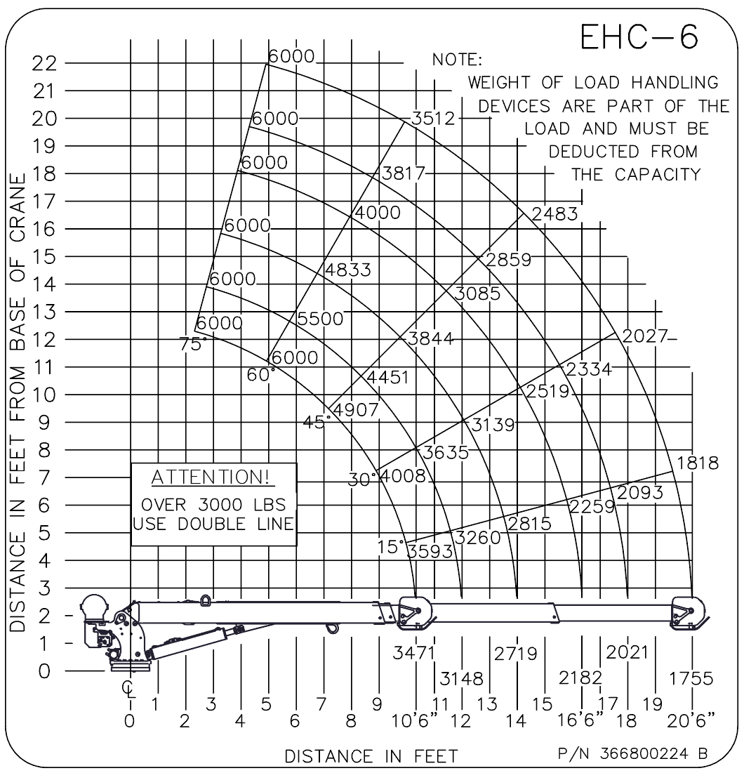

Figure 1: EHC-6 Load Chart